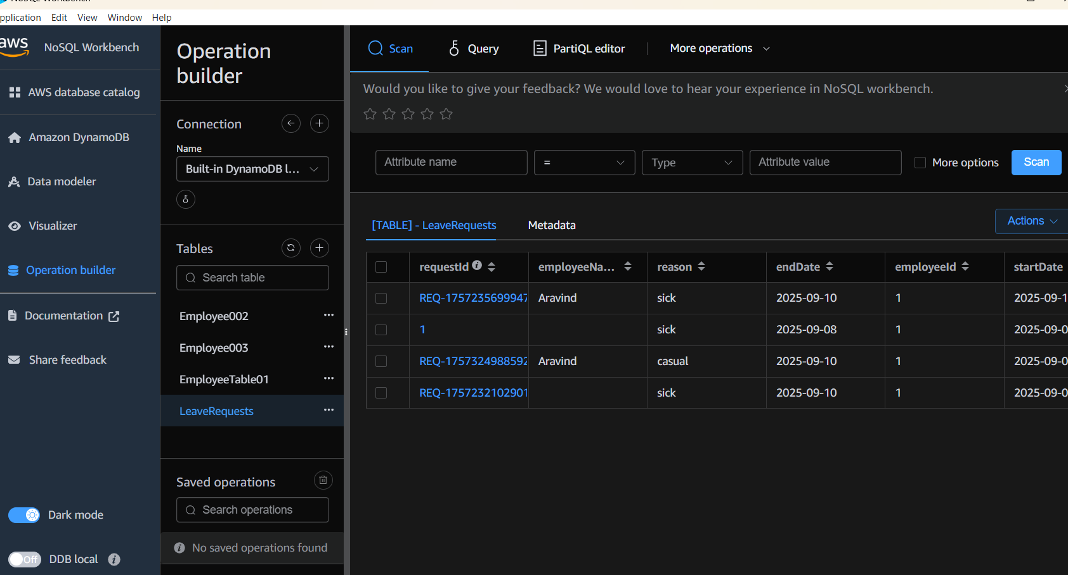

# ============================================================
# ✅ AWS CLI Configuration (One-time setup)
# ============================================================
aws configure
# Provide: Access Key, Secret Key, Region (ap-south-1), Output (json)

# ============================================================
# ✅ Identity Check
# ============================================================
aws sts get-caller-identity

# ============================================================
# ✅ List Tables (to verify before/after creation)
# ============================================================
aws dynamodb list-tables

# ============================================================
# ✅ Task 1: Create Table (Employee)
# ============================================================
aws dynamodb create-table \
--table-name Employee \
--attribute-definitions AttributeName=ID,AttributeType=N AttributeName=EmpName,AttributeType=S \
--key-schema AttributeName=ID,KeyType=HASH AttributeName=EmpName,KeyType=RANGE \
--provisioned-throughput ReadCapacityUnits=5,WriteCapacityUnits=5

# Insert sample data
aws dynamodb put-item \
--table-name Employee \
--item '{"ID": {"N": "1001"}, "EmpName": {"S": "Prasunamba"}}'

aws dynamodb put-item \
--table-name Employee \
--item '{"ID": {"N": "1002"}, "EmpName": {"S": "Meher"}}'

# Query
aws dynamodb query \
--table-name Employee \
--key-condition-expression "ID = :ID" \
--expression-attribute-values '{":ID":{"N":"1001"}}'

# Update
aws dynamodb update-item \
--table-name Employee \
--key '{"ID": {"N": "1001"}, "EmpName": {"S": "Prasunamba"}}' \
--update-expression "set info = :info" \
--expression-attribute-values '{":info": {"S": "MK"}}'

# Delete
aws dynamodb delete-item \
--table-name Employee \
--key '{"ID": {"N": "1001"}, "EmpName":{"S": "Prasunamba"}}'

# Describe Table
aws dynamodb describe-table --table-name Employee

# Scan Table
aws dynamodb scan --table-name Employee

# ============================================================
# ✅ Backup & Restore
# ============================================================
# Create backup
aws dynamodb create-backup \
--table-name Employee \
--backup-name MyEmployeeBackup

# List backups
aws dynamodb list-backups

# Describe a backup
aws dynamodb describe-backup \
--backup-arn arn:aws:dynamodb:ap-south-1:xxxx:table/Employee/backup/xxxx

# Restore table from backup
aws dynamodb restore-table-from-backup \
--target-table-name EmployeeRestored \
--backup-arn arn:aws:dynamodb:ap-south-1:xxxx:table/Employee/backup/xxxx

# ============================================================
# ✅ Home Task: Create Custom Table (EmployeeDetails)
# ============================================================
aws dynamodb create-table \
--table-name EmployeeDetails \
--attribute-definitions AttributeName=EmpID,AttributeType=N AttributeName=EmpName,AttributeType=S \
--key-schema AttributeName=EmpID,KeyType=HASH AttributeName=EmpName,KeyType=RANGE \
--provisioned-throughput ReadCapacityUnits=5,WriteCapacityUnits=5

# Insert 5 records
aws dynamodb put-item \
--table-name EmployeeDetails \
--item '{"EmpID": {"N": "101"}, "EmpName": {"S": "Ravi"}, "Department": {"S": "IT"}, "Salary": {"N": "50000"}}'

aws dynamodb put-item \
--table-name EmployeeDetails \
--item '{"EmpID": {"N": "102"}, "EmpName": {"S": "Sita"}, "Department": {"S": "HR"}, "Salary": {"N": "45000"}}'

aws dynamodb put-item \
--table-name EmployeeDetails \
--item '{"EmpID": {"N": "103"}, "EmpName": {"S": "Meher"}, "Department": {"S": "Finance"}, "Salary": {"N": "60000"}}'

aws dynamodb put-item \
--table-name EmployeeDetails \
--item '{"EmpID": {"N": "104"}, "EmpName": {"S": "Anil"}, "Department": {"S": "Sales"}, "Salary": {"N": "55000"}}'

aws dynamodb put-item \
--table-name EmployeeDetails \
--item '{"EmpID": {"N": "105"}, "EmpName": {"S": "Prasunamba"}, "Department": {"S": "Marketing"}, "Salary": {"N": "47000"}}'

# Query one record
aws dynamodb query \
--table-name EmployeeDetails \
--key-condition-expression "EmpID = :id" \
--expression-attribute-values '{":id":{"N":"103"}}'

# Update salary for EmpID 103
aws dynamodb update-item \
--table-name EmployeeDetails \
--key '{"EmpID": {"N": "103"}, "EmpName": {"S": "Meher"}}' \
--update-expression "set Salary = :salary" \
--expression-attribute-values '{":salary": {"N": "65000"}}'

# Delete EmpID 105
aws dynamodb delete-item \
--table-name EmployeeDetails \
--key '{"EmpID": {"N": "105"}, "EmpName": {"S": "Prasunamba"}}'

# Scan all records
aws dynamodb scan --table-name EmployeeDetails

# ============================================================
# ✅ End of Script
# ============================================================

